Bahria University

*Lahore Campus*

*Department of Computer Sciences*

Data Communication & Networking

Assignment # 02

Instructor Name: Mr. Muhammad Dawood Akram

**Program:** BSCS

**Semester: 4th**

1. **What is the bandwidth of a signal that can be decomposed into five sine waves with frequencies at 0, 20, 50, 100, and 200 Hz? All peak amplitudes are the same. Draw the bandwidth**

| | | | | |

| | | | | |

| | | | | |

|----------------- |-----------------|---------------- |----------------|-----------------|

0Hz 20Hz 50Hz 100Hz 200Hz

1. **A nonperiodic composite signal contains frequencies from 10 to 30 KHz. The peak amplitude is 10 V for the lowest and the highest signals and is 30 V for the 20-KHz signal. Assuming that the amplitudes change gradually from the minimum to the maximum, draw the frequency spectrum.**

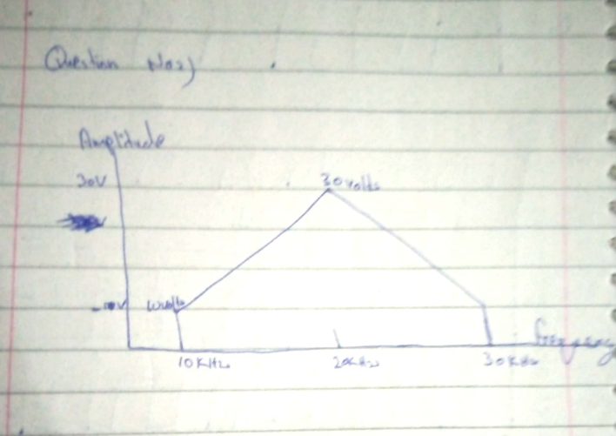

1. **What is the total delay for a frame of size 5 million bits that is being sent on a link with 10 routers each having a queuing time of 2 μs and a processing time of 1 μs. The length of the link is 2000 Km. The speed of light inside the link is 2 × 108 m/s. The link has a bandwidth of 5 Mbps. Which component of the total delay is dominant? Which one is negligible?**

**Transmission Delay:**

{Transmission Delay} = {Frame Size}{Link Bandwidth}}Transmission Delay=

**Link Bandwidth**

**Frame Size**

**​**

**{Transmission Delay} = {5,000,000 ,{bits}}{5 \times 10^6 , \{bits/s}} = 1 , {s}Transmission Delay=**5×10

**6**bits

**5,000,000bits**=1s

**Propagation Delay:**

**{Propagation Delay} = {Length of the Link}}{{Speed of Light}}Propagation Delay=**

**Speed of Light**

**Length of the Link**

**​**

**{Propagation Delay} = {2000 \times 10^3 , {m}}{2 times 10^8, \{m/s}} = 0.01\, {s} = 10 , {ms}Propagation Delay=**2×10

**8**m/s

**2000×10**

**3**m

**​**=0.01s=10ms

**Queuing Delay (per router):**

**{Total Queuing Delay} ={Number of Routers} Queuing Time per Router}Total Queuing Delay=Number of Routers×Queuing Time per Router**

**{Total Queuing Delay} = 10 times 2 , mu{s} = 20 , mu{s}Total Queuing Delay=10×2μs=20μs**

**Processing Delay (per router):**

**{Total Processing Delay} = {Number of Routers} times {Processing Time per Router}Total Processing Delay=Number of Routers×Processing Time per Router**

**{Total Processing Delay} = 10 times 1 , mu{s} = 10 , mu{s}Total Processing Delay=10×1μs=10μs**

1. **Draw the graph of the NRZ-L scheme using each of the following data streams, assuming that the last signal level has been positive. Repeat the problem for NRZ-I and Manchester Schemes**

***a. 00000000 b. 11111111 c. 01010101 d. 00110011***

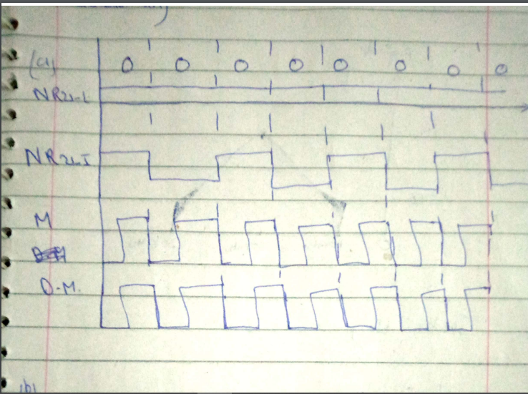

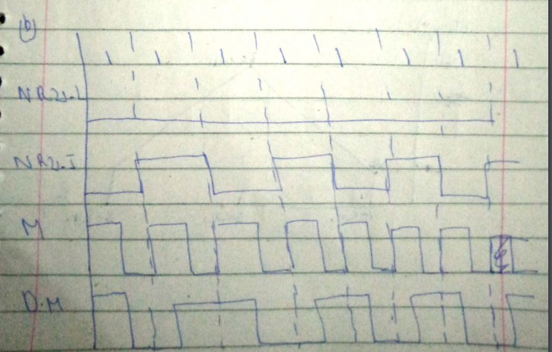

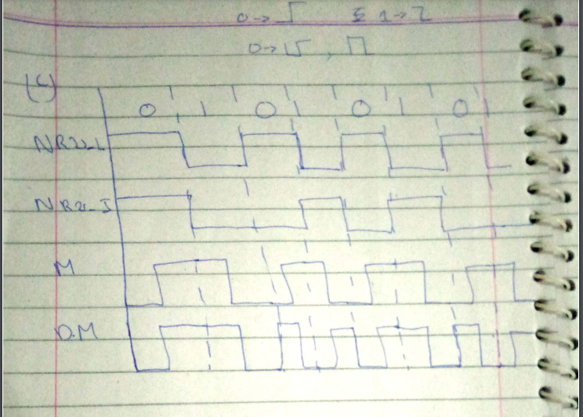

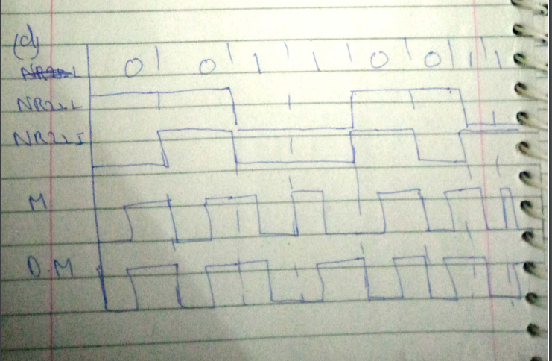

1. **We have sampled a low-pass signal with a bandwidth of 200 KHz using 1024 levels of quantization.**

**a. Calculate the bit rate of the digitized signal.**

**Bit Rate=Sampling Rate×Bits per Sample**

Therefore, the sampling rate is 2×200KHz=400KHz.

the number of bits required to represent each sample is \log_2(1024) = 10log2

​

(1024)=10 bits.

Bit Rate=400KHz×10bits per sample=4Mbps

**b. Calculate the SNRdB for this signal.**

**SNRdB=6.02×Bits per Sample+1.76**

Given that there are 10 bits per sample:

SNRdB = 6.02 \times 10 + 1.76 = 60.2 + 1.76 = 61.96 SNRdB=6.02×10+1.76=60.2+1.76=61.96dB

**c. Calculate the PCM bandwidth of this signal.**

**PCM Bandwidth=Bit Rate×Oversampling Factor**

Therefore, the PCM bandwidth is the same as the bit rate, which is 4Mbps.